MEDIA PACKET, NOVEMBER 2015

The Paris climate accord: U.S. must lead on more ambitious goals by pricing carbon

A rising fee on CO2, coupled with rebates to households and tariffs on imports, can provide the economic incentive to drive the emissions reductions needed to ward off catastrophic climate change.

When the United Nations Conference on Climate Change opens in Paris on Nov. 30, there is reason to hope that the global community will, at long last, take steps toward reducing the enormous risks associated with greenhouse gas emissions.

Those risks, once thought to be in the near to distant future, are already apparent in:

- The increasingly common flooding of Miami streets due to rising seas.
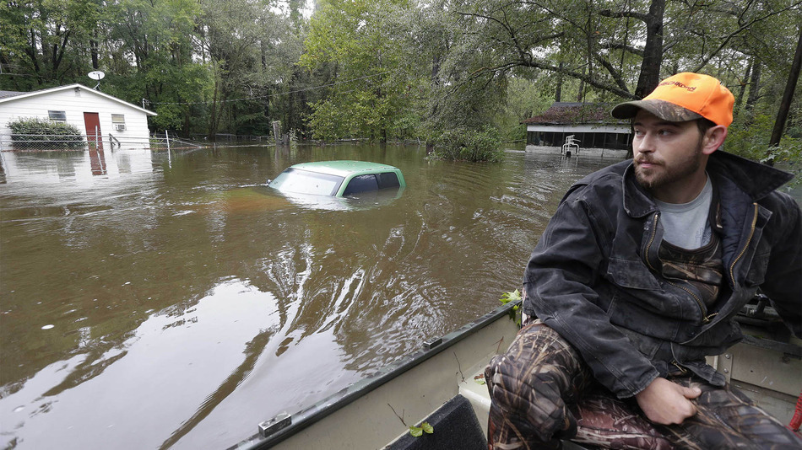
- Powerful storms that can dump 10 to 20 inches of rain in just 24 hours, as we saw recently in South Carolina (at left).
- The burning of five million acres of Alaskan wilderness in a single year.
- Refugees streaming into Europe, fleeing a Syrian civil war exacerbated by a prolonged drought between 2006 and 2010.
- Snowpack in California’s Sierra Nevada Mountains being the lowest in 500 years, threatening water supplies for drinking, agriculture and electrical generation.

There is little doubt that climate change is affecting our world here and now. The big question is whether we will allow the earth’s climate to change beyond humanity’s capacity to adapt. After many failed attempts, the nations of the world are poised to reach an agreement to reduce emissions of the heat-trapping gases that threaten to make large parts of the earth unlivable.

The good news is that 129 out of 156 countries, accounting for 90 percent of global greenhouse gas emissions, have submitted their intended nationally determined contributions (INDCs) to the Paris agreement.

The bad news is that even if all these countries meet their pledges, the world will still fall woefully short of the emissions reductions needed to stay with the 2 degrees Celsius threshold of warming that scientists say is manageable. As Christiana Figueres, Executive Secretary of the UN Framework Convention on Climate Change, has said, the Paris agreement "is a very good step ... but it is not enough." The Paris accord will be a work in progress, with nations needing to periodically revise their commitments to be more ambitious.

What will motivate greater ambition on emissions targets? How can the nations of the world do better?

Putting a price on carbon

It all comes down to economics.

Fuels that emit greenhouse gases when burned – coal, oil and gas – have long been the preferred means of powering our lives and moving goods and people from one place to another. However, these fuels remain artificially cheap, with their immediate price not reflecting their actual costs. Those true costs are instead borne by our whole society in the form of medical bills to treat respiratory and heart ailments, damage from storms made worse by global warming, food shortages from increasingly-frequent droughts and floods, and greater military costs associated with the “threat multiplier” of climate change.

Economists, both conservative and liberal, tell us that the best way to correct this market failure is to put a price on carbon. In fact, almost 40 countries and more than 20 cities, states and provinces already use carbon pricing mechanisms or are planning to implement them. The Carbon Pricing Panel, which includes heads of state, city, regional and business leaders, was recently launched to urge countries and businesses around the world to put a price on carbon.

Between the two principal mechanisms employed to price carbon – carbon tax or cap-and-trade – many economists prefer the carbon tax because of its simplicity and the certainty it provides for businesses and investors.

Despite support from corporations – including major oil companies – for a carbon price, the United States has yet to adopt this most effective means of reducing greenhouse gas emissions. Instead, because Congress has failed to enact a legislative solution, the U.S. is relying on regulations implemented by the executive branch. These regulations are now under attack in the federal courts, and in Congress.

In lieu of legislation to address climate change, the EPA rules – known as the Clean Power Plan – are an essential step toward reducing U.S. carbon emissions. But these regulations cover only the power sector, and are therefore a poor substitute for an economy-wide price on carbon.

From a global perspective, if we hope to motivate other nations to make more ambitious commitments on reducing emissions, regulations on power plants offer little leverage.

However, a U.S. policy that provides a rising fee on carbon, and includes tariffs levied on imports from nations that do not have equivalent carbon pricing, would provide the leverage needed to motivate greater emissions reductions.

Carbon Fee and Dividend: A win-win-win

Given the risk our nation and our world faces in a business-as-usual scenario on climate change, “Just say no” is not a suitable response to the President’s Clean Power Plan. Opponents of EPA regulations can find an acceptable – and better – alternative with a market-based solution known as Carbon Fee and Dividend.

It works like this: We would place a fee on the amount of CO2 that a fuel will emit when burned, starting at $15 per ton of CO2. The fee would increase annually by $10 per ton of CO2, and be assessed as far upstream as practical (such as the mine, well, or port of entry into the United States). All revenue from the fee would be returned equally to all households, preferably as direct monthly payments. In order to maintain a level playing field for American businesses and to motivate other nations to price carbon, border tariffs would be applied to goods from nations that do not have equivalent carbon pricing. Revenue from the border tariff would then be used to compensate U.S. businesses exporting to nations lacking a similar carbon price.

Critics of carbon pricing often say it will have a detrimental effect on the economy, calling it a “job killer.” Under Carbon Fee and Dividend, however, the exact opposite is true. A study conducted by Regional Economic Models, Inc. (REMI) found that after 20 years the policy would add 2.8 million jobs to the economy, primarily because returning the revenue to households acts as a stimulus.

As for emissions reductions, the REMI study found that in 20 years Carbon Fee and Dividend would cut emissions 52 percent below 1990 levels, putting the U.S. on a trajectory to hit 80 percent reductions by mid-century, a target many experts say is necessary to stay within the 2C threshold.

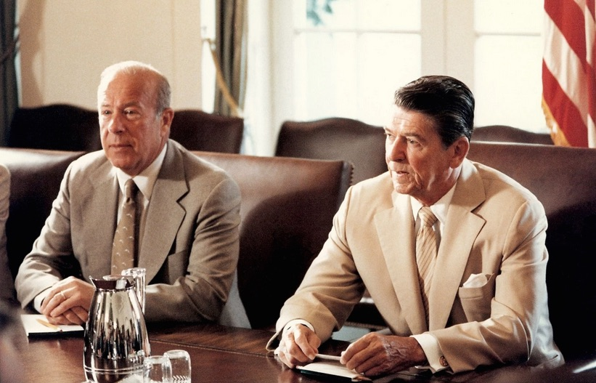
Support for Carbon Fee and Dividend comes from Republican statesman George Shultz (at left), who was Secretary of State under Ronald Reagan and Treasury Secretary under Richard Nixon. Shultz calls the solution an “insurance policy” against the risks of climate change, and something Ronald Reagan might have done.

A revenue-neutral carbon price also has the support of conservatives like Jerry Taylor of the Niskanen Center, Andrew Moylan of the R Street Institute, and Bush economic advisor Greg Mankiw.

With Carbon Fee and Dividend, we achieve the triple win of reducing emissions, growing the economy and motivating other nations to follow our lead. From a conservative viewpoint, it’s the perfect policy, creating jobs without increasing the size of government.

Will Congress act?

Political pundits and media outlets scoff at the notion that Congress will ever enact legislation that prices carbon; the popular narrative says that Republicans are too much in denial about climate change to do so. Nevertheless, what we at Citizens’ Climate Lobby are seeing in meetings with congressional offices – both Republican and Democratic – leads us to believe otherwise.

This past June, 800 CCL volunteers met with nearly 500 House and Senate offices. In meetings with Republicans, there were very few instances of pushback from staff or members of Congress about the science of climate change. Instead, there was keen interest, active listening, productive discussions and — in some cases — expressions of support for our proposal. The unspoken agreement seemed to be: "Let's not argue about the science; let's talk about solutions and where we might find common ground."

Recent events in Congress give rise to more optimism.

A number of Republicans have planted seeds of hope in both the House and the Senate. In September, Congressman Chris Gibson (R-NY) introduced a resolution on climate change, which now has 11 GOP cosponsors, stating that the House should commit “to working constructively, using our tradition of American ingenuity, innovation, and exceptionalism, to create and support economically viable, and broadly supported private and public solutions.”

Last month, Sen. Kelly Ayotte (R-NH), along with three Republican colleagues, announced the “formation of a Senate Energy and Environment Working Group that will focus on ways we can protect our environment and climate while also bolstering clean energy innovation that helps drive job creation.”

More and more Republicans are realizing that their party’s failure to come to the table on climate change has effectively ceded policy to the executive branch, resulting in solutions – such as government regulations – that are not to their liking. The efforts by Republicans in the House and Senate to engage on the climate issue are a hopeful sign that bipartisan legislation can eventually be attained.

With the historic agreement anticipated in Paris, our civilization may take a step back from the precipice of climate catastrophe. But there is still much work left to secure a livable world for future generations. Congress can begin that work in earnest by enacting a revenue-neutral fee on carbon that sets the standard for other nations.

