MEDIA PACKET, NOVEMBER 2016

With executive actions on climate change likely to be undone, it’s time for Congress to step up

With the likelihood of the Clean Power Plan being scrapped under a President Trump, it’s time for Congress to act on climate change. The market-based solution of putting a fee on carbon and returning revenue to households provides common ground for Republicans and Democrats.

As shockwaves ripple throughout the world in the wake of the U.S. presidential election, advocates for a livable climate fear that the progress made to rein in carbon pollution will suffer serious setbacks under a Trump presidency. With the current vehicle for reducing emissions – the Clean Power Plan – almost certain to be dismantled, Congress must step into the breach to provide a solution that will honor America’s global commitment on climate change.

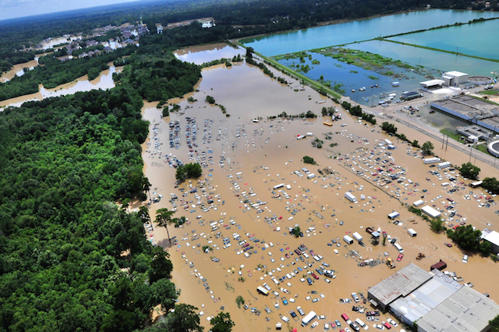
Recent natural disasters in the U.S. bearing the fingerprints of climate change underline the urgency to limit future risks associated with a warming world.

In August, 2 feet of rain (yes, FEET) fell in parts of Louisiana over a 48-hour period. According to the New Orleans Times-Picayune, the rains caused floods that damaged more than 60,000 houses and necessitated the rescue of 30,000 people. Other analysts estimated that as many as 188,729 occupied houses and 507,495 people -- 11 percent of the state's population -- were ‘affected’ by the flood.” Thirteen people lost their lives, with initial estimates placing the flood damage at more than $8 billion.

As reported in the New York Times, a team of analysts, which included scientists from the National Oceanic and Atmospheric Administration, concluded that climate change increased the chances of such torrential rain in the area by at least 40 percent:

“But it’s probably much closer to a doubling of the probability” of such an event, or a 100 percent increase, said Heidi Cullen, chief scientist for Climate Central, the research organization that coordinated the study. “Climate change played a very clear and quantifiable role,” she added.

During the horrific flooding in North Carolina that followed Hurricane Matthew, when up to 18 inches of rain fell, authorities estimate that 100,000 homes, businesses and government buildings sustained a collective $1.5 billion worth of damage. At least 26 people in the state died. While analysis of the role of climate change has yet to be completed, we know that warmer ocean and land temperatures allow the atmosphere to hold more water, which is then released with storms like Matthew.

If we allow greenhouse gas emissions to continue unabated, the disasters we witnessed in Louisiana and North Carolina will become more commonplace, exceeding our capacity to adapt and recover from such catastrophes. The costs are high and long-lived: four years after Superstorm Sandy devastated the Northeast, coastal communities are still recovering.

Optimism and concern

Amid these disasters comes the hopeful news that the movement to rein in climate change is finally gaining traction globally. At the Paris climate conference last year, 195 nations signed an agreement committing to the goal of containing global warming to 2 degrees Celsius above pre-industrial levels, with each nation submitting emissions-reduction targets. Enough countries have since ratified the agreement to allow it to officially take effect on Nov. 4.

But the ink of the signatures was hardly dry before critics pointed out that commitments to reduce emissions would fall far short of the 2C goal. Indeed, an analysis published in Nature estimated that current commitments would be on track for warming between 2.6 and 3.1 C above pre-industrial levels by the end of the century. Realizing their commitments were insufficient, countries have agreed to revisit those goals periodically with an eye toward ratcheting emissions down further.

The biggest concern, though, is that the commitment from the U.S. – the world’s second largest emitter of carbon dioxide -- relied heavily upon executive actions directing the Environmental Protection Agency to limit greenhouse gas emissions at electrical generation facilities. That program, known as the Clean Power Plan, will almost certainly by scrapped in a Trump administration.

The future livability of our planet, therefore, now rests in the hands of our legislative branch.

A market-based solution

The next Congress must enact a solution that is more efficient and effective – and more durable -- than government regulation. The policy that stands the best chance of bridging the partisan divide, attracting support from both Republicans and Democrats, is a revenue-neutral fee on carbon.

Known as Carbon Fee and Dividend, this approach levies a steadily rising fee on the amount of carbon dioxide that a fuel emits when burned. Bureaucracy would be minimized by assessing the fee as far “upstream” as possible, such as at the oil or gas well, coal mine, port of entry. To shield families from the financial burden of the fee, and to prevent it from being an economic drag, the revenue from the fee would be divided equally among all households and returned as monthly payments (hence, the dividend). The policy would also utilize border adjustment tariffs on goods imported from nations lacking an equivalent price on carbon, thereby maintaining a level playing field for American companies.

How effective would this policy be?

Regional Economic Models, Inc. (REMI), analyzed a fee on carbon that would increase annually by $10 per ton on CO2, with net revenue returned equally to all households. Their conclusions were impressive. REMI found that just 20 years of Carbon Fee and Dividend would reduce emissions 50 percent below 1990 levels. On the economic side, REMI found the policy would add 2.8 million jobs (see chart below) because of all the revenue being recycled into the economy. Over the same time period, reductions in pollutants that often accompany carbon pollution would would prevent 230,000 premature deaths.

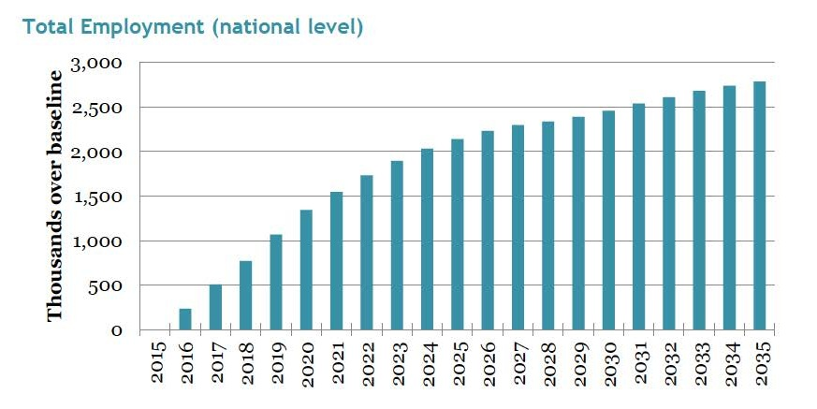

Carbon Fee and Dividend offers a market-based alternative to government regulations and subsidies that Republicans eschew. Revenue-neutrality would also prevent an increase in governmental spending -- a major selling point for GOP members of Congress, and the reason that conservative think tanks like R Street, Niskanen Center and republicEn support a revenue-neutral fee on carbon.

For Democrats, Carbon Fee and Dividend offers financial protection to low- and middle-income families and improves health incomes in at-risk communities, all while achieving the emissions reductions we need.

Breaking the partisan impasse

But what are the odds that Democrats and Republicans could actually set aside their differences and come together on meaningful climate legislation? The truth is that they’re much better than one might think. Recent developments pointing to a shift toward bipartisan cooperation include:

- In September of 2015, Rep. Chris Gibson (R-NY) introduced a resolution acknowledging the threat of climate change and the need for action (H Res. 424) which has since acquired 14 Republican cosponsors.
- Many signers of the Gibson resolution have now joined with Democrats to form the bipartisan House Climate Solutions Caucus to explore policies to address climate change. The caucus consists of 10 Republicans and 10 Democrats.
- California Republican Ed Royce and Oregon Democrat Earl Blumenauer have introduced legislation to deal with the increasing risk of floods, which climate change has substantially worsened in recent years.
- Arizona Republican Paul Gosar and Colorado Democrat Jared Polis have introduced legislation to spur the development of clean energy on federal land.

With polls showing more and more support for action on climate change, many Republicans in Congress are considering solutions that will address their constituents’ concerns. A revenue-neutral fee on carbon, which employs market forces to reduce emissions, offers a solution that adheres to conservative principles of accountability and small government.

After an election that has exposed the great risk of depending on executive actions to reduce climate threats, Congress must step up and provide a more durable solution, one that will honor America’s commitment to the Paris climate agreement. A revenue-neutral fee on carbon provides common ground for effective bipartisan action, offering the promise of a livable world for future generations.

