MEDIA PACKET, FEBRUARY 16, 2016

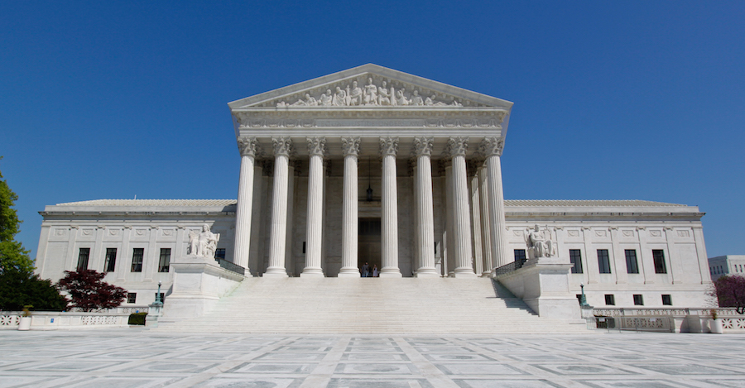

It’s time to stop playing games with our climate and put a price on carbon

The recent Supreme Court stay on the Clean Power Plan threatens international climate cooperation and underscores the tenuous nature of executive actions on climate change.

You could almost hear a collective gasp among the international community last week when the U.S. Supreme Court voted to delay the implementation of President Obama’s Clean Power Plan until legal challenges are resolved — a process that will, at best, carry over to the middle of next year.

Last December, thanks in no small part to U.S. leadership, the nations of the world joined to chart a course to avert future climate catastrophe. Although the commitments made to reduce greenhouse gas emissions fell far below what is necessary to limit the increase in global temperatures to manageable levels, the Paris accord was hailed as a major breakthrough. It is now widely viewed as a critical first step towards an eventual ratcheting up of international commitments to reduce carbon pollution.

Underpinning the historic agreement among nearly 200 nations is a simple concept: We’ll do it if you do it.

President Obama went to Paris promising that the United States would reduce emissions 26 to 28 percent by the year 2025. He was able to make that pledge because of a new EPA regulation, known as the Clean Power Plan, aimed at reducing carbon dioxide emissions at new and existing electric power plants. A strong commitment from the U.S. was essential to getting other nations to make pledges of their own.

Court decision raises uncertainty

That commitment, however, is based on an executive action now facing aggressive challenges in U.S. courts, which — especially in combination with last week’s Supreme Court stay — raise international doubts about the ability of America to fulfill its obligations.

Last year, as reported in Inside Climate News, the State Department’s Todd Stern filed an affidavit pointing to the connection between the Clean Power Plan and the Paris negotiations:

"Based on my experience as the lead U.S. climate negotiator, I believe that the ambition and implementation of many other countries' current and future emission control actions depends significantly on the understanding by their leaders of the seriousness of the U.S. commitment to address emissions.

"For many countries, willingness to take action depends on collective trust that the major emitters are taking action. If a stay of the Clean Power Plan is granted, there is a real threat that some other countries, including major emitters, might reduce the intensity or pace of their actions or even fail to achieve their commitments."

A similar statement was filed by former Secretary of State Madeleine Albright in the U.S. Court of Appeals for the District of Columbia Circuit in January. Albright wrote:

A stay of the EPA regulation would "irreparably undermine the international commitments and momentum to finally begin curbing the greenhouse gas emissions that are driving extremely dangerous climate change across the globe. Specifically, a stay of the Clean Power Plan would likely cast doubt on the ability of the United States to achieve domestic emission reductions and lead other nations to delay implementing emission reductions. Such a loss of momentum could quickly snowball, causing more nations to signal their intent to delay. If the loss of momentum were great enough, it could not be repaired even following a decision on the merits upholding the Clean Power Plan."

Though the Appeals Court rejected the request by 29 states to grant a stay in the implementation of the Clean Power Plan until legal challenges are resolved, the U.S. Supreme Court overturned that decision in a 5-4 ruling. The high court’s unexpected move raised doubts about whether the EPA regulation would eventually be upheld.

With the surprising death of Supreme Court Justice Antonin Scalia, President Obama could nominate a justice more likely to support the Clean Power Plan, easing concerns that the EPA regulation might be struck down. But Scalia’s death has already touched off a partisan battle to choose his replacement, with Senate Majority Leader Mitch McConnell vowing to block any replacement until Obama leaves office.

A legislative solution is needed

All of this raises an important question: Should the future of our world be vulnerable to court challenges and election-year politics?

It’s time for the U.S. to stop playing games with our climate and enact a more effective and permanent solution, one that reassures the rest of the world that we are serious about our commitment to reducing greenhouse gas pollution. If designed the right way, legislation to price carbon could not only achieve the necessary emissions reductions and motivate other nations to follow our lead, but also be a boon to our economy.

Carbon Fee and Dividend is a simple, transparent solution that can cut carbon, create jobs and move other nations to price carbon. Because it is revenue neutral – meaning it will not increase the size of government – it can attract support from both sides of the aisle in Congress. George Shultz, former Secretary of State under President Reagan, supports this solution, calling it “an insurance policy” against the catastrophic consequences that could arise from climate change.

The policy works like this: A fee would be placed on the amount carbon dioxide a given fuel would emit when burned, starting at $15 per ton of CO2 and increasing by $10 per ton each year. All revenue collected from the fee would be divided into equal shares and returned to households, giving families the extra income to cover any increases in energy costs. At the same time, border adjustment tariffs would be placed on imports from nations that do not have an equivalent price on carbon, maintaining a level playing field for American companies and discouraging U.S. companies from off-shoring their carbon emissions (money from the tariff would be used to compensate U.S. firms exporting to nations lacking an equivalent carbon price).

What would such a policy do?

In 2014, a study by Regional Economic Models, Inc. (REMI) of CCL’s Carbon Fee and Dividend proposal found that it would:

- Reduce CO2 emissions 33 percent below 1990 levels after 10 years, and 52 percent below 1990 levels after 20 years.
- Because of the economic stimulus of recycling carbon fee revenue into the pockets of people likely to spend it, 2.1 million jobs would be added after 10 years, and 2.8 million after 20 years.
- Average GDP would grow $70 billion to $85 billion annually over 20 years — a $1.375 trillion boost to economic output during that time.
- Reduced air pollution would prevent 13,000 premature deaths annually after 10 years. A total of 227,000 premature deaths would be prevented over 20 years.
- After 10 years, a family of four would receive a monthly payment of $288 per month ($3,450 a year). After 20 years, the monthly payment would be $396.

Is Congress ready to act?

What are the chances of Congress enacting effective legislation to address climate change? Most Americans view our legislative branch as more dysfunctional and partisan than ever. Given the acrimony currently on display, what hope is there for a bipartisan initiative?

Actually, there is more hope than most people realize.

Last September, 11 Republicans in the House of Representatives, led by Rep. Chris Gibson of New York, introduced a resolution (H. Res 424) stating that climate change could have an adverse impact on our nation and that Congress should start working on solutions. The resolution was seen as a major breakthrough that opened the door for Republicans to engage on the issue. Since its introduction, two more Republicans have come on as cosponsors for a total of 13.

The unprecendented Gibson climate resolution was followed by another breakthrough earlier this month: The formation of the bipartisan House Climate Solutions Caucus, co-chaired by Rep. Carlos Curbelo (R-FL) and Rep. Ted Deutch (D-FL). Both congressmen represent districts in South Florida, an area considered to be especially vulnerable to climate change-related rising seas and worsening storms. Serving in his first term, Curbelo has been outspoken on the climate issue since he came into office, even touring the Everglades with President Obama to call attention to the problem on Earth Day last year.

"There shouldn’t be this false orthodoxy, where if you’re a Democrat you want to solve this problem and if you’re a Republican you want to ignore it," Curbelo told Bloomberg Business. "That just makes no sense."

In papers filed to form the caucus, Curbelo and Deutch said its purpose is to “explore policy options that address the impacts, causes, and challenges of our changing climate. The Caucus will serve as an organization to educate members on economically-viable options to reduce climate risk and protect our nation’s economy, security, infrastructure, agriculture, water supply and public safety.”

In the Senate, meanwhile, Sen. Kelly Ayotte (R-NH) announced the formation of the Senate Energy and Environment Working Group in late October to “focus on ways we can protect our environment and climate while also bolstering clean energy innovation that helps drive job creation.”

Although these Republican initiatives have gone virtually unnoticed in the media, they offer the hope that serious discussions will soon be under way to introduce a bipartisan legislative solution to climate change — a solution that will have much greater resilience than executive orders.

As the oft-quoted line from the film “Apollo 13” goes, “Failure is not an option.” That sentiment is especially true when the stakes are no less than the preservation of a livable world.

The Supreme Court’s decision to delay the Clean Power Plan exposes the folly of relying solely on executive action to solve the most critical problem our civilization has ever faced. As more and more Republicans express a willingness to come to the table, Congress can and must work in earnest to enact a market-based climate solution. Carbon Fee and Dividend is the solution that can bridge the partisan divide.

CONTACT: Steve Valk, 404-769-7461, steve@citizensclimate.org

