Action Sheet, April 2017

Monthly Meeting, Saturday, April 8, 2017
at 10:00 a.m. Pacific / 1:00 p.m. Eastern

Two Join Options
- To connect by video conference, go to zoom.us, select “Join A Meeting” and enter 2017201717 for the meeting ID, OR use this URL: http://cclusa.org/meeting
- To connect by phone: For either phone option, you’ll enter 2017201717 as the meeting ID. 1-646-558-8656 (please use if you have unlimited calling) or toll-free 1-877-369-0926.
Note: To improve video quality, close open applications (and browser windows). If your Internet connection is poor, you can connect by phone.
If you have problems connecting, please contact Zoom’s 24/7 support at 888.799.9666.

CONFERENCE CALL GUEST:
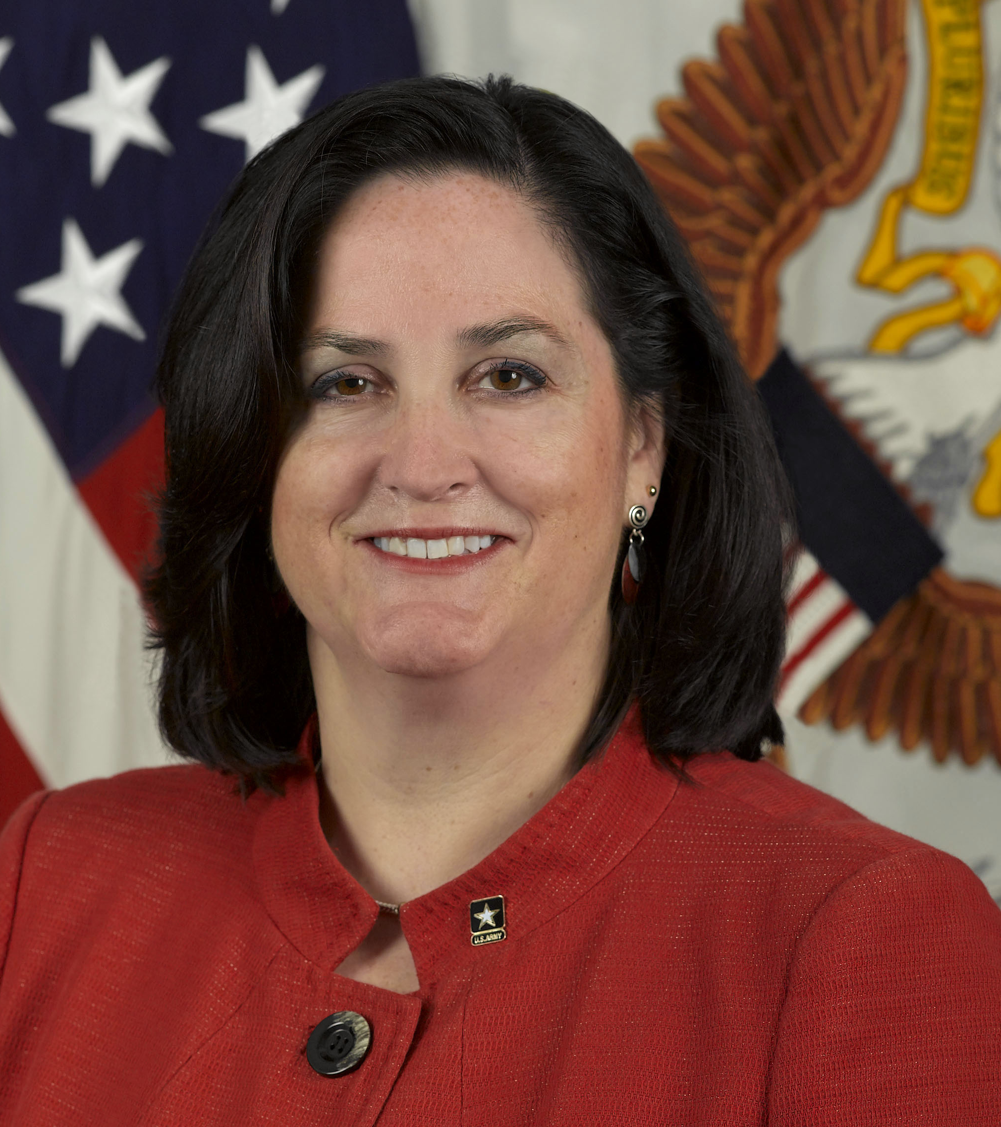
Katherine Hammack, former Asst. Secretary of the Army
Katherine Hammack is an experienced leader in the energy and environmental field who was appointed by President Obama, and confirmed by the Senate, to be the Assistant Secretary of the Army for Installations, Energy and Environment. She worked with the Obama administration, focusing on Net Zero (energy, water and waste), resiliency and sustainability for all of the Army’s installations worldwide.
Katherine is an expert on Climate Change and Sustainability strategies and oversaw LEED certification for the largest LEED project in the world when she was with Ernst & Young. She has extensively spoken around the world at conferences and in radio interviews regarding sustainability, resilience and net zero strategies. Download the speaker’s slides.

Actions

- Pitch CCL’s media packet for Earth Day editorials.
- Write to House Republicans and ask them to cosponsor the Republican Climate Resolution. Ask House Democrats to support revenue neutral carbon fees.
- Practice the communications skills exercise in this month’s action sheet.

ACTION
Pitch Earth Day media packet to editorial writers

On Earth Day, April 22, many newspapers will mark the occasion with an environmentally-themed editorial. This provides us with one of the best opportunities during the year to generate endorsements for CCL’s Carbon Fee and Dividend proposal. To assist this effort, we have distributed a media packet that groups can pitch to editorial writers with a request for the newspaper to endorse CCL’s solution. The four-page packet lays out the case for Congress to step up on climate change with a fee on carbon that returns revenue to households. It provides links to source material that editorial writers will find useful.

Ways to pitch:

- Meet with editorial board: The best way to pitch the packet and our request for an endorsement is to meet with the editorial board or the opinion editor at your newspaper. Assign a small team within your group – three should suffice – to schedule and meet with the newspaper at least three days prior to Earth Day. Watch this webinar on meeting with editorial boards or search “editorial boards” on CCL Community for more info.
- Send media packet: If your group has met with the editorial board or opinion editor within the last six months, a meeting, while preferred, may not be necessary. If someone in your group has been communicating with a contact on the editorial board, they can email the packet with a request for an editorial endorsement. If there is no response within a day or two, follow up with a phone call.
- Can’t get a meeting? If your group has not met with the editorial board and a meeting is not possible, have someone send the packet by email to the opinion editor and follow up by phone.

Sample note to pitch editorial (can be modified for a meeting request):

Hi, [EDITOR’S NAME],

This is [YOUR NAME] with the [YOUR CITY] chapter of Citizens’ Climate Lobby. Earth Day is coming up – April 22 – and we were wondering if you’re planning an editorial to mark the occasion. If so, the topic that seems most pressing, especially given current political circumstances, is climate change and how we can maintain momentum to reduce greenhouse gas emissions. With the new administration rolling back initiatives that deal with climate change, such as the Clean Power Plan, it’s time for Congress to enact legislation that places an effective price on carbon. A market-based solution that is gathering strong support in conservative circles – carbon fee and dividend – provides the best hope of bringing Republicans and Democrats together. An endorsement from the [NEWSPAPER’S NAME] would provide the encouragement our representatives and senators need to get behind this solution. I’ve attached our media packet, which provides background on this proposal and the changing atmosphere in Congress that gives cause for hope. Will you consider an editorial on this topic?

Thank you,

[YOUR NAME]
[YOUR PHONE]

ACTION

Write your member of Congress

House Republicans: Sponsor the Republican Climate Resolution
House Democrats: Support revenue neutral carbon fees

As part of progressing toward introducing legislation for a revenue-neutral carbon fee we need to increase the number of Republicans publicly supporting action on climate and to solidify Democratic support for a full dividend. The re-introduction of the Republican Climate Resolution last month generated a lot of publicity. Let’s build on that momentum by getting more sponsors on it. Since Democrats can’t sign onto that resolution, we have a different ask for them: Support revenue neutrality as the best bipartisan approach.

We suggest that you take time at your meeting this month for volunteers to write to their representatives.

- Tell House Republicans about the Republican Climate Resolution and ask them to sponsor it. If they are already a sponsor, thank them.
- Tell House Democrats how the Republican Climate Resolution opens the door to bipartisan action on climate change, and the most helpful thing they could do is to support putting a fee on carbon with the money fully rebated back to households. Tell them why you support a 100% dividend, and ask them to do likewise.

Letter tips: Put a header on your letter or in the email subject line such as "Republican Climate Resolution" or "Support Carbon Fee and Dividend". Keep your letter short—no longer than one page. Don’t mix in other issues, and clearly state what you want them to do. Search “Writing a letter” on CCL Community for more tips. Send hand-written letters to the district office, or use CCL’s online action tool to email Republicans and to email Democrats.

10-minute Communication Skills exercise

Conservatives may find an appeal to a pristine past more moving.

Recent research indicates that appealing to a nostalgic past and contrasting it to the present can be more effective in reaching conservatives than what we often do, which is to offer a negative view of the future. This research was described in a December 2016 Think Progress article as follows:
Conservatives who dismiss science might see climate change differently if exposed to messages that evoke the more verdant past rather than an apocalyptic future, according to a new study.
“The trick is to present a very positive past standard, and then draw attention to the less positive present,” said Matthew Baldwin, a post-doctoral fellow in psychology at the University of Cologne, whose latest research appears in the Proceedings of the National Academy of Sciences.
“Our studies describe in words and pictures what the past used to be like, an almost Eden-like version of the planet, one with clean forests and little traffic and pollution. Then we draw a comparison to today, without any references to the future,” Baldwin said. “It is much harder to avoid the reality of change when the comparison is to the beautiful planet in its ‘untouched’ form.”
…Baldwin and his colleague, Joris Lammers, conducted a series of online experiments drawing upon more than 1,600 participants in the United States. Conservatives responded more favorably to messages focused on the past, rather than on the future.

CCL member Judy Berlfein* had remarkable success with her conservative neighbor when she tried this approach. It takes a little work to come up with these stories, so the suggested activity for your meetings is to work together to create one. Use these stories in conversations, in letters to Congress or the paper, and in lobby meetings.

Exercise: With a partner, construct a story that is true for you, that evokes the unsullied pristine past and compares it to conditions today. Resist the urge to extend it into the future. Take 3-4 minutes to work in pairs, and allow a few minutes to share the stories afterwards. Feel free to also share them with Madeleine@citizensclimate.org.

*From Judy Berlfein’s email to her neighbor: I appreciate your concern for not wanting to pollute God's beautiful creation. Hopefully, we can work together to make sure our water, air, and food remain as pure and healthy as they were in former times. I remember being able to drink water from a river as a kid. It was such a delightful experience. I can't say the air was all that clean in Los Angeles when I was growing up. It's actually clearer now than it was then, but perhaps when my mother was a child, the mountains were ever present and not hidden behind the smog-filled air.

